**LAB # 3**

**Objective:**

Learn the basics about the Packet Tracer software. Also **follow** basic SHOW commands which are defined below and give required explanation of the results.

**Description/Theory:**

**Introduction**

Packet Tracer is a protocol simulator developed by Dennis Frezzo and his team at Cisco Systems. Packet Tracer (PT) is a powerful and dynamic tool that displays the various protocols used in networking, in either Real Time or Simulation mode. This includes layer 2 protocols such as Ethernet and PPP, layer 3 protocols such as IP, ICMP, and ARP, and layer 4 protocols such as TCP and UDP. Routing protocols can also be traced.

The screenshot for the packet tracer is shown below

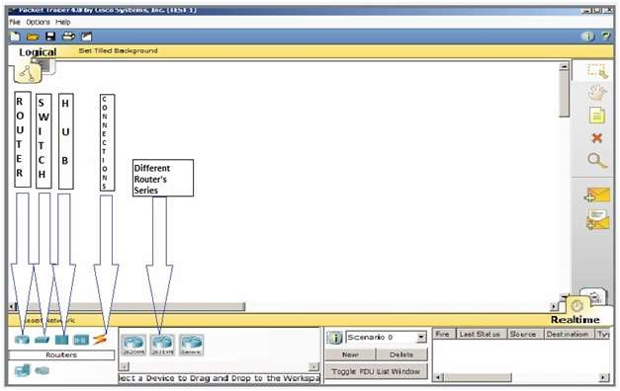

**Figure1 : Snap Shot Of Packet Tracer**

**Router:**

# Modes Used In Packet Tracer for Router

There are three types of modes:

## User mode

Router>

**▪** Where user can access different commands and login to the main device.

Router> en

## Configuration mode/Privilege mode

Router#

▪ Where the user can make changes and configure the device manually.

Router# config terminal

## Global Configuration mode

Router(config)#

▪ Where the user can make changes and to access the interfaces and assigning ip addresses respectively.

**LAB Task 1:**

Apply the following commands on router in Packet Tracer Software and attach the result in the form of screen shot in lab file, and also give necessary explanation.

# Basic Show Commands on Router

## Router#show running-config

Show the active configuration in memory. The currently active configuration script running on the router is referred to as the running-config on the routers command-line interface. Note that privileged mode is required. The running configuration script is not automatically saved on a Cisco router, and will be lost in the event of power failure. The running configuration must be manually saved with the 'copy' command

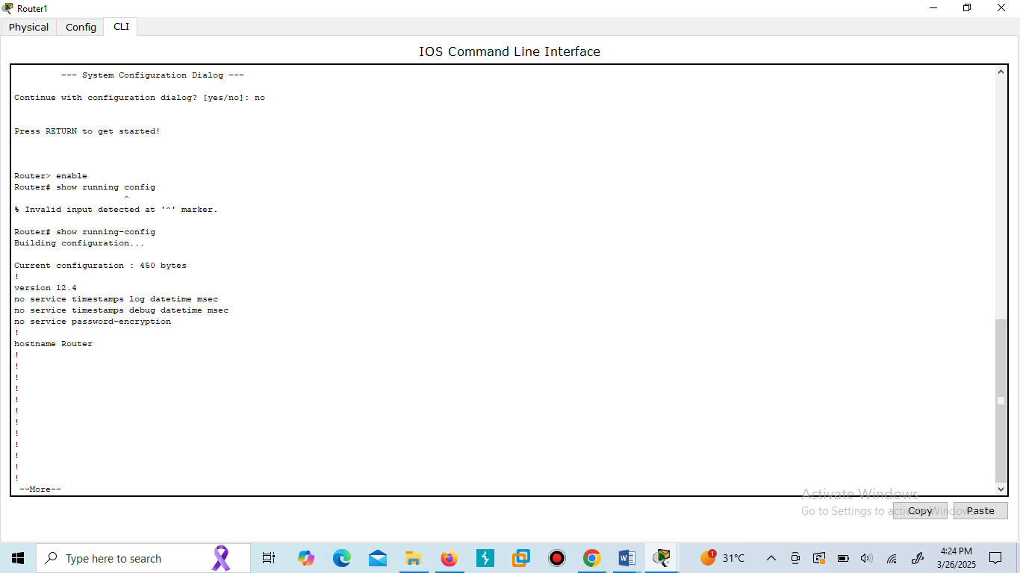

## Router#show flash

Flash memory is a special kind of memory on the router that contains the operating system image file(s). Unlike regular router memory, Flash memory continues to maintain the file image even after power is lost.

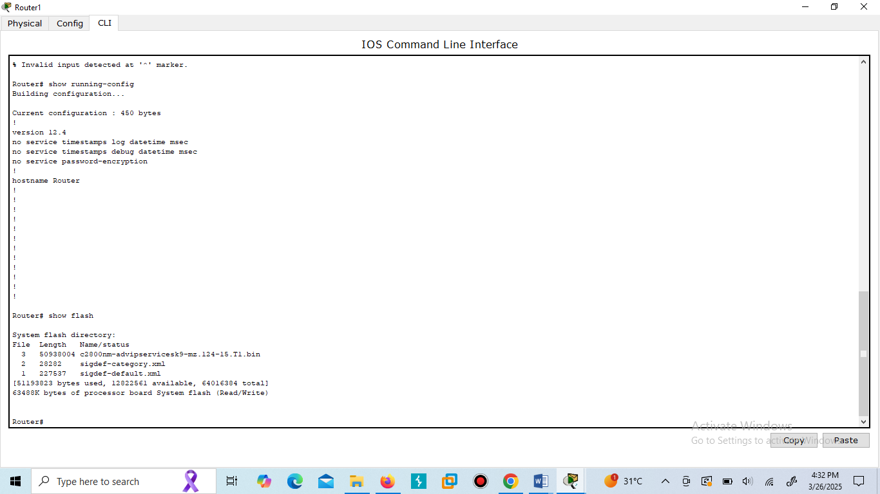

## Router#show history

The routers Command Line Interface (CLI) maintains by default the last 10 commands you have entered in memory. It shows the history of last 10 used commands.

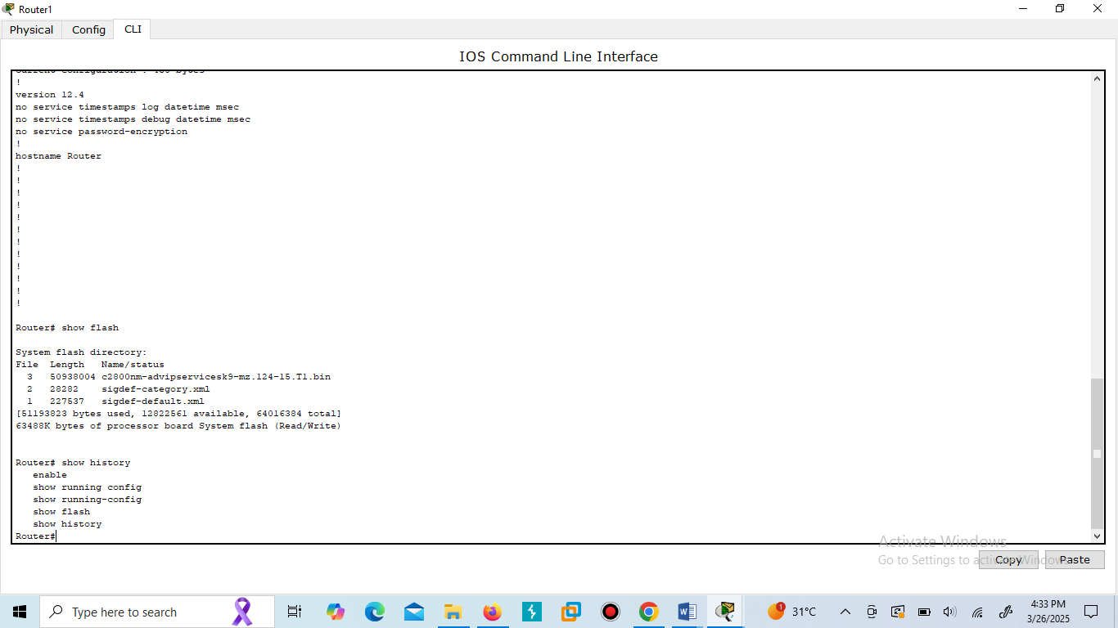

To retrieve the previous command you typed:

**Press the up arrow**

To retrieve the next command you typed:

**Press the down arrow**

## Router#show protocols

Use this command to view the status of the current layer 3 routed protocols running on your router

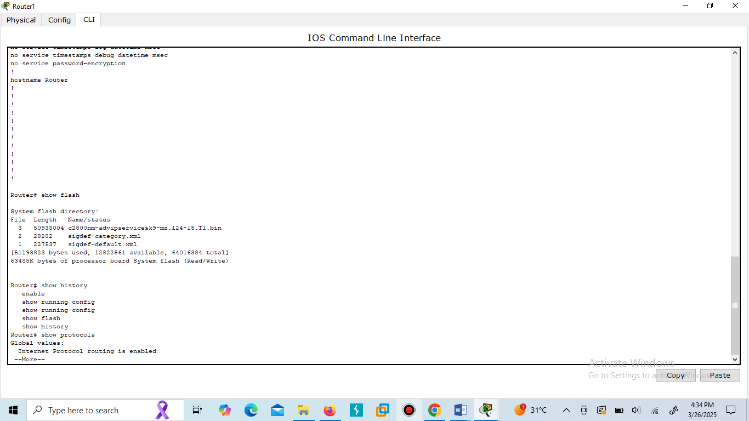

**Router#show version**

Show detailed information about Cisco IOS Software and its specifications. This command will give you critical information, such as: router platform type, operating system revision, operating system last boot time and file location, amount of memory, number of interfaces, and configuration register

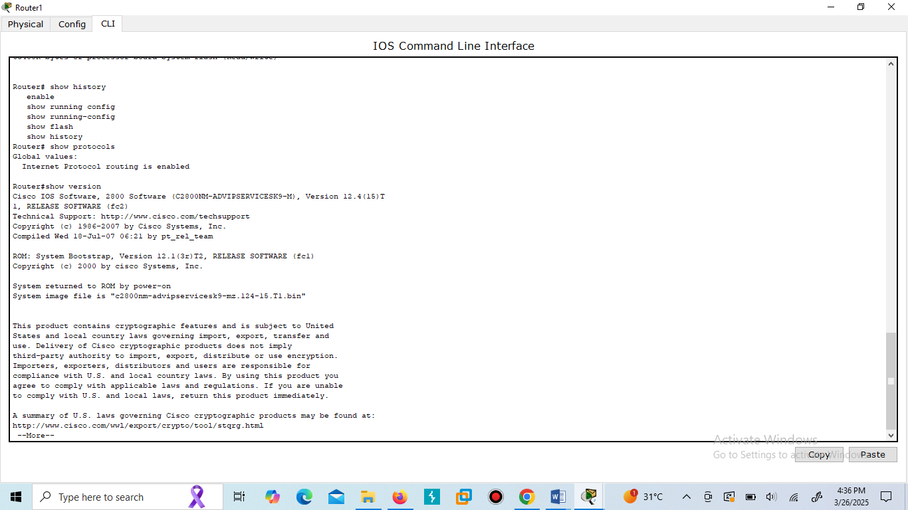

**Router#show clock**

Will show you default Router clock

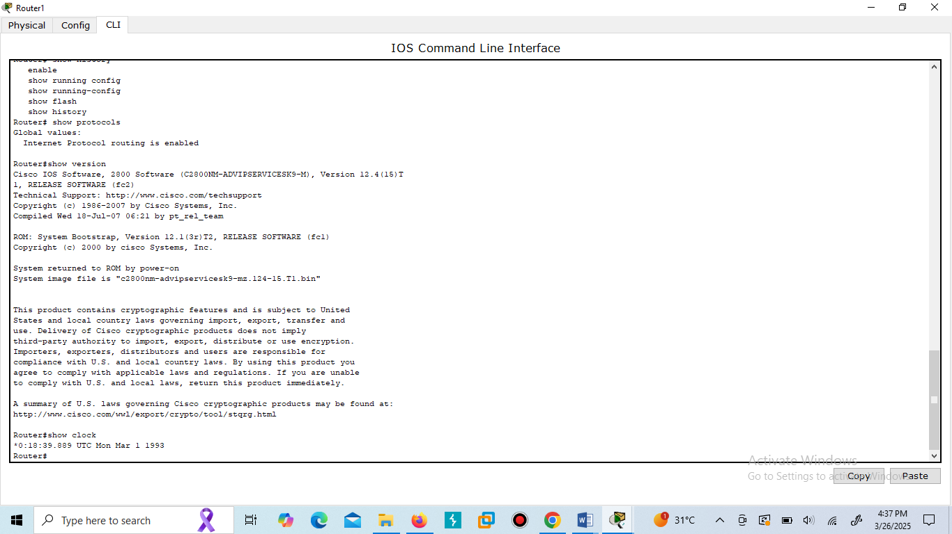

**Router#show hosts**

Will display a cached list of hosts and all of their interfaces IP addresses.

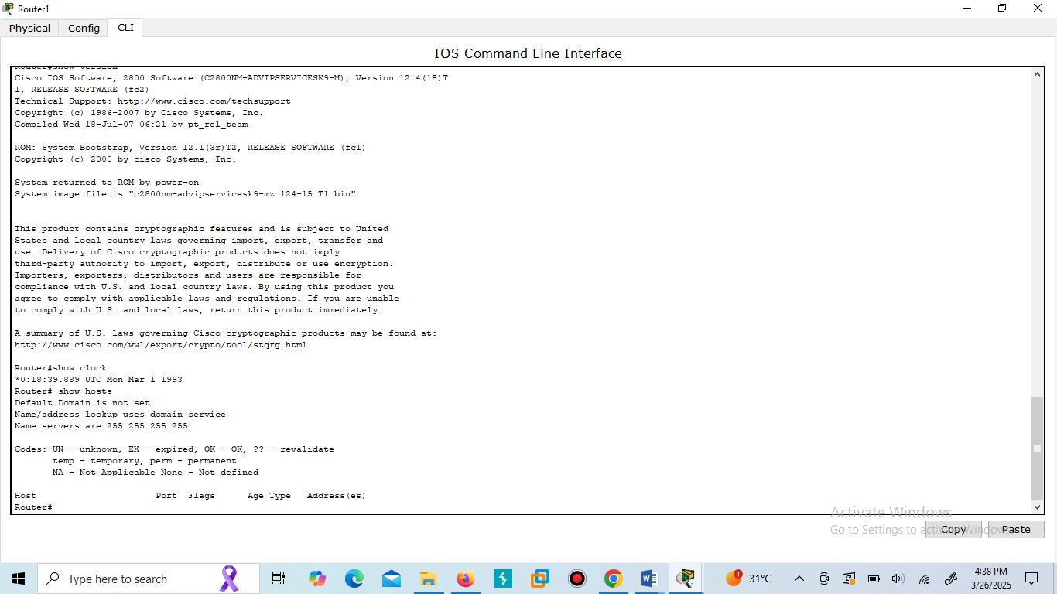

**Router#show users**

Will show a list of all users who are connected to the router.

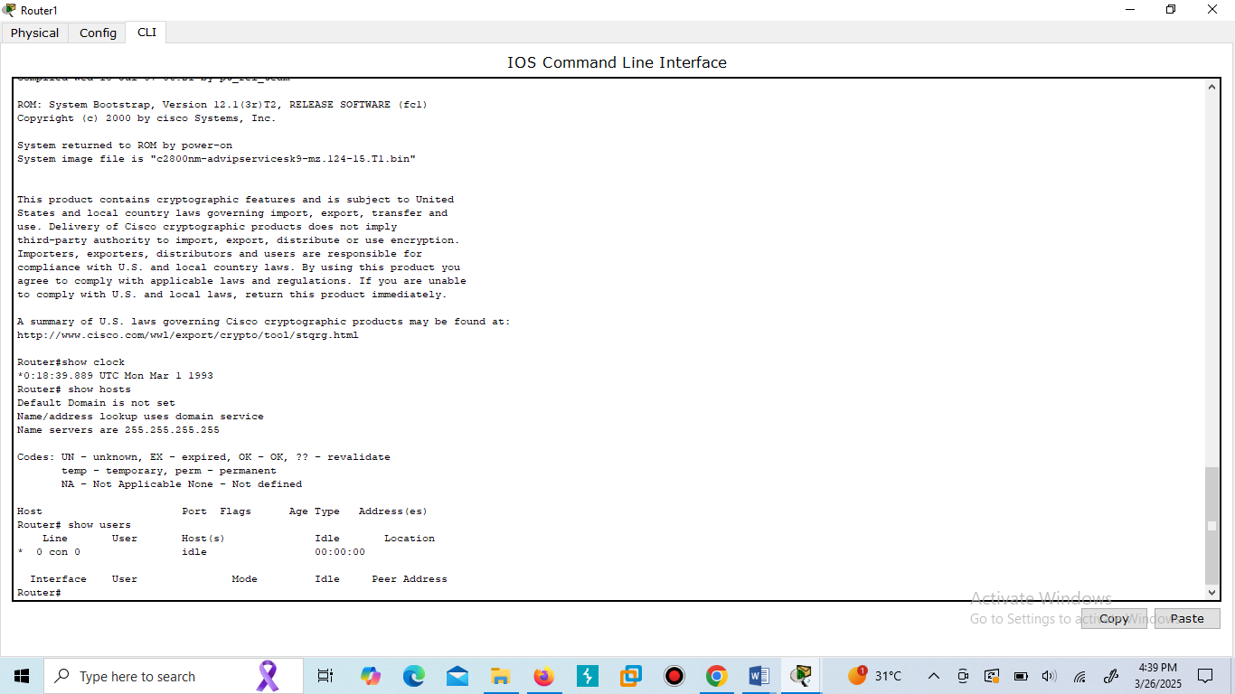

## Router#show interfaces

Will give you detailed information about each and all kinds of interfaces used by the router. And also tell which interface UP, Down and Administratively down.

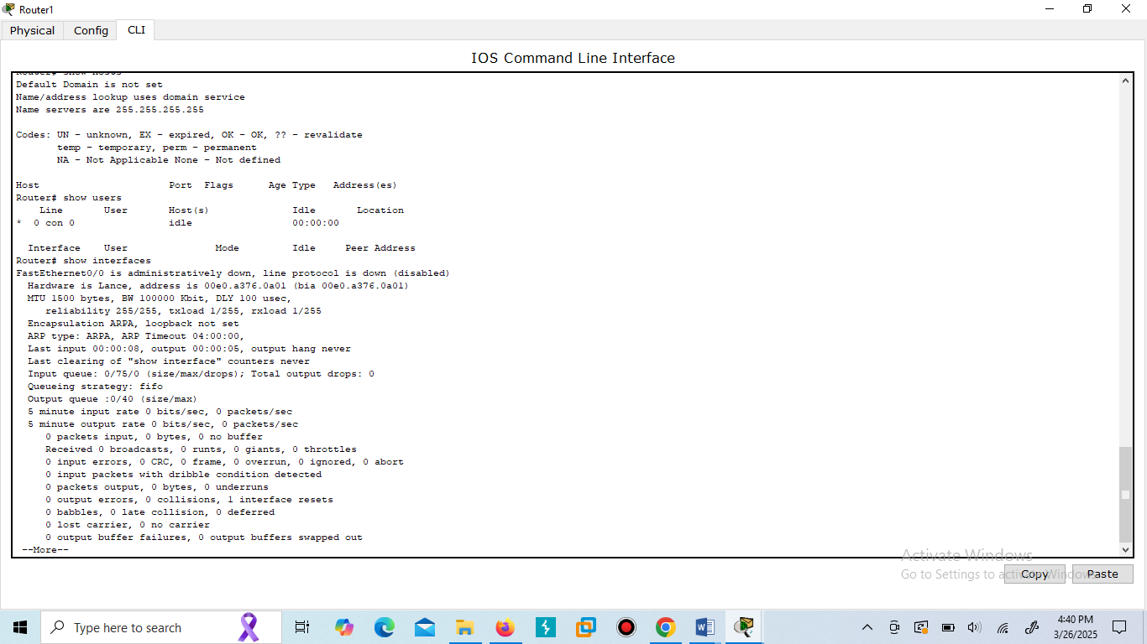

## Router#show ip interface brief

This command will show brief descriptions about interface. This command mostly used in troubleshooting. There may be three possible conditions of status

**UP :-** interface is up and operational

**DOWN :-** physical link is detected but there are some problem in configurations. **Administratively down :-** port is disable by shutdown command ( Default mode of any port on router.)

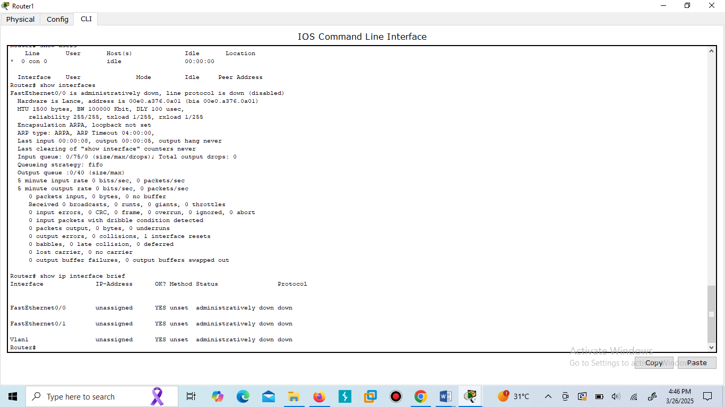

## Router#show ip route

This command will give a detail about known route. Router will not forward packet if route is not shown here for that packet. Router’s routing decision is made by this routing table. And also tell which IP is directly connected to the interface and which IP is indirectly connected to the interface in the route.

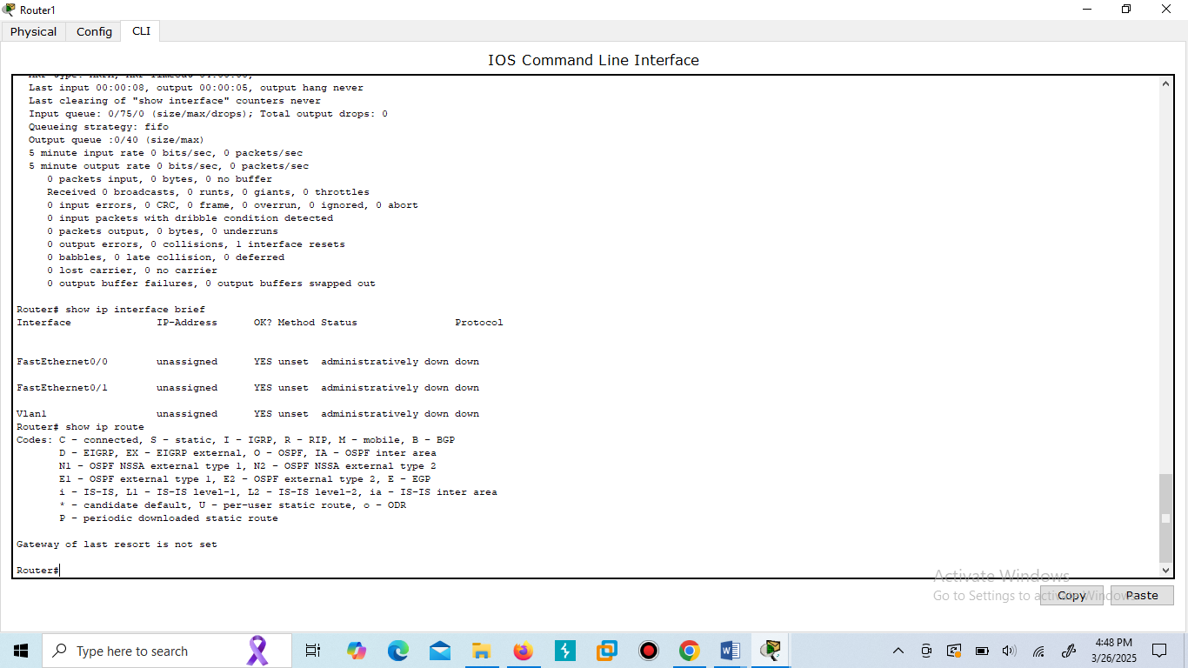

## Router#show ip protocols

It shows the detailed of the routing protocol which is used by the router.

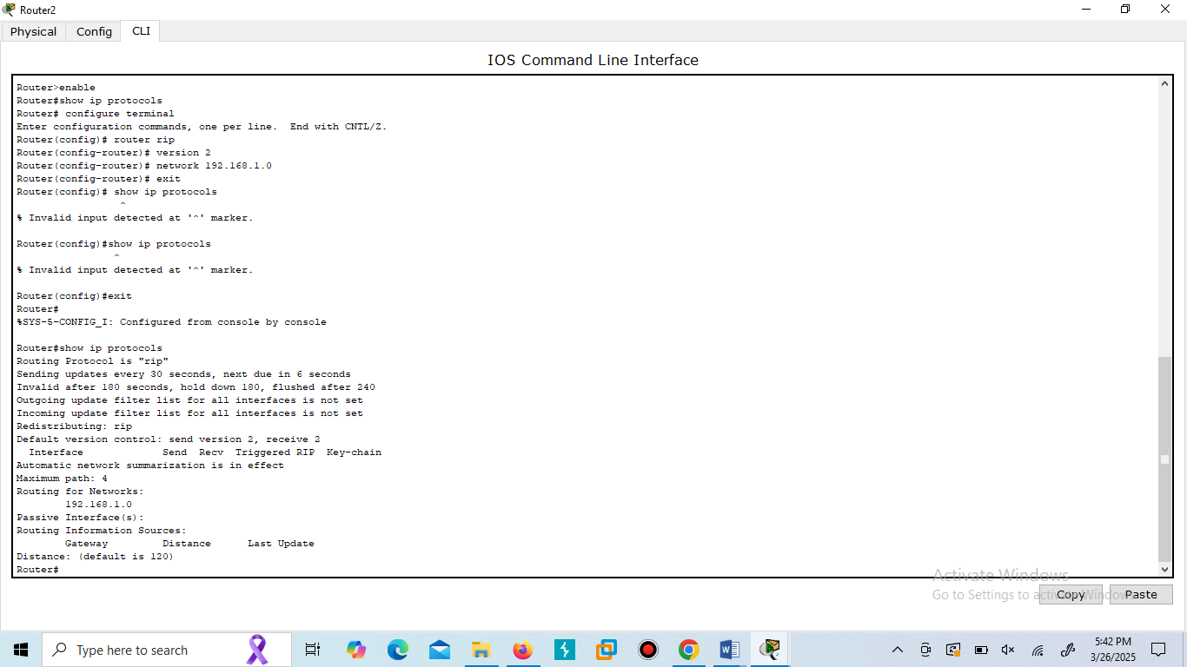

**Switch:**

# Modes Used In Packet Tracer for Switch

There are three types of modes:

## User mode

Switch>

**▪** Where user can access different commands and login to the main device.

Switch> en

## Configuration mode/Privilege mode

Switch#

▪ Where the user can make changes and configure the device manually.

Switch# config terminal

## Global Configuration mode

Switch(config)#

▪ Where the user can make changes and to access the interfaces and assigning ip addresses respectively.

## Sub-Interface Configure mode

Switch(config-if)#

▪ Where the user can assign ip addresses and protocols to the interfaces respectively.

**LAB Task 2:**

Apply the following commands on switch in Packet Tracer Software and attach the result in the form of screen shot in lab file, and also give necessary explanation.

# Basic Show Commands on Switch

## Switch#show running-config

Show the active configuration in memory. The currently active configuration script running on the Switch is referred to as the running-config on the Switchs command-line interface. Note that privileged mode is required. Enter privileged EXEC mode by typing: Switch> enable. The running configuration script is not automatically saved on a Cisco Switch, and will be lost in the event of power failure. The running configuration must be manually saved with the 'copy' command

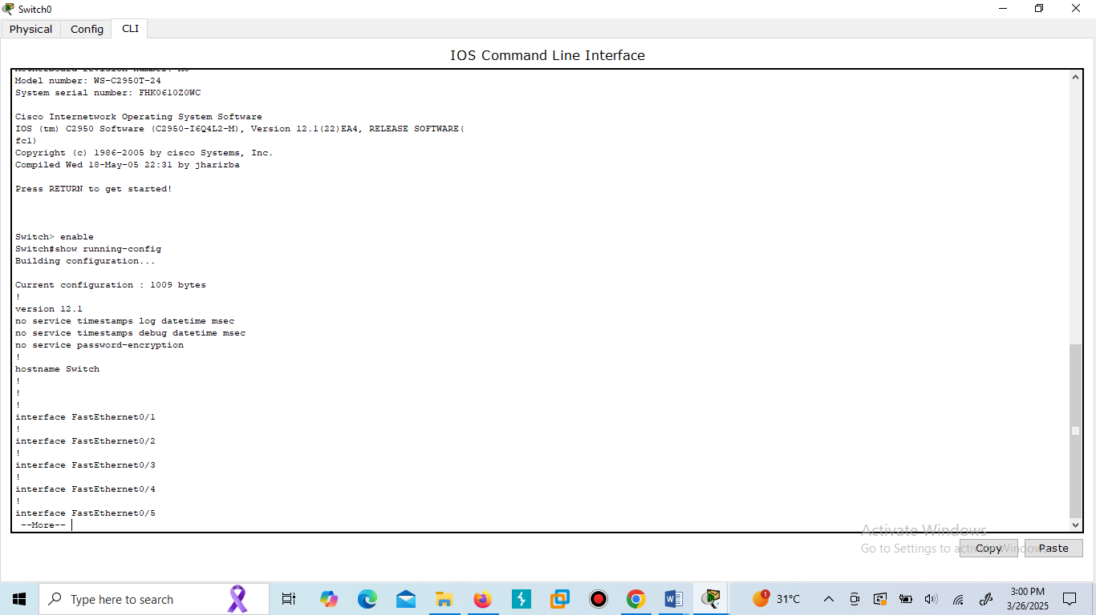

**To change the Hostname of Switch**

**Switch(config)# Hostname switch 2950**

Changes the **switch name** to "Switch2950".

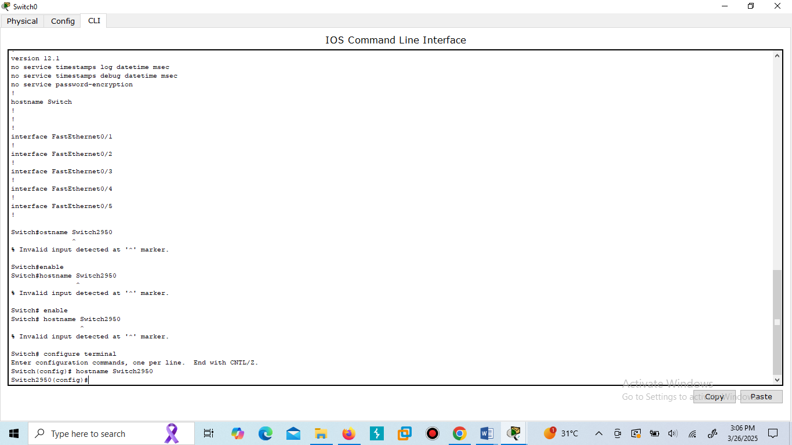

## Switch#show flash

Flash memory is a special kind of memory on the Switch that contains the operating system image file(s). Unlike regular Switch memory, Flash memory continues to maintain the file image even after power is lost.

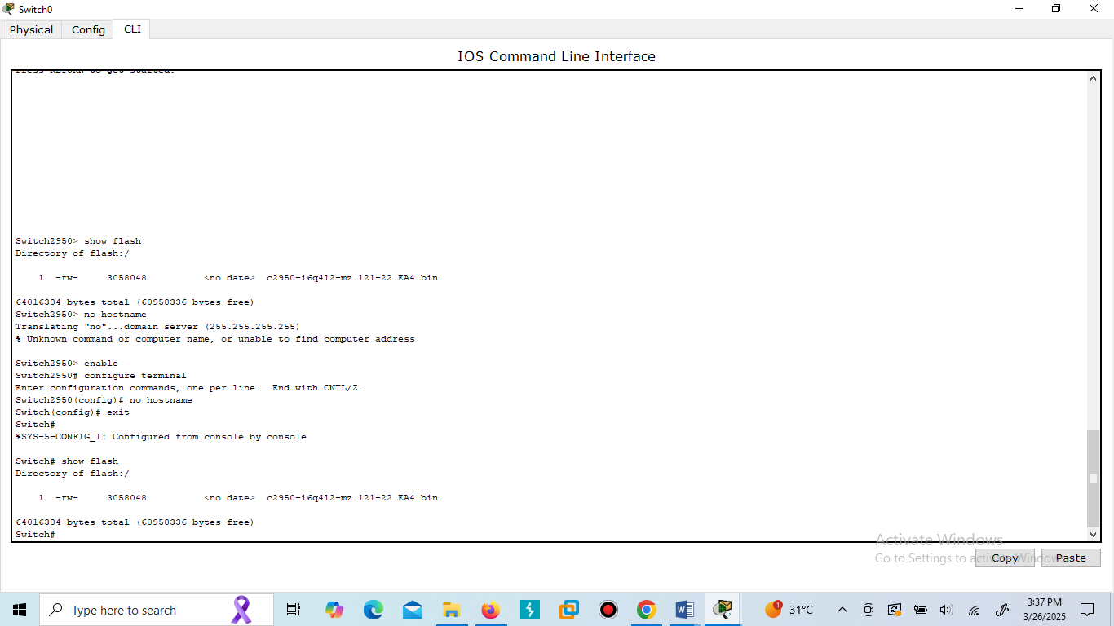

## Switch#show history

The Switches Command Line Interface (CLI) maintains by default the last 10 commands you have entered in memory.

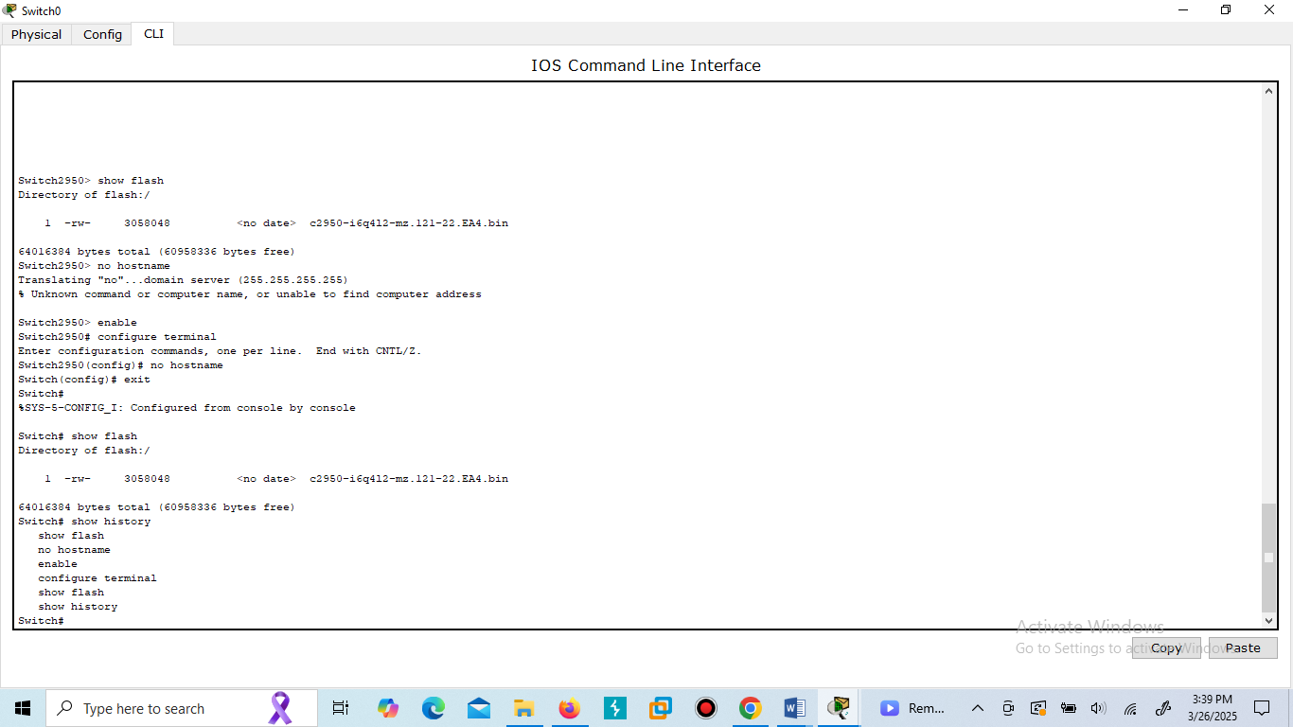

To retrieve the previous command you typed:

**Press the up arrow**

To retrieve the next command you typed:

**Press the down arrow**

## Switch#show version

Show detailed information about Cisco IOS Software and its specifications. This command will give you critical information, such as: Switch platform type, operating system revision, operating system last boot time and file location, amount of memory, number of interfaces, and configuration register

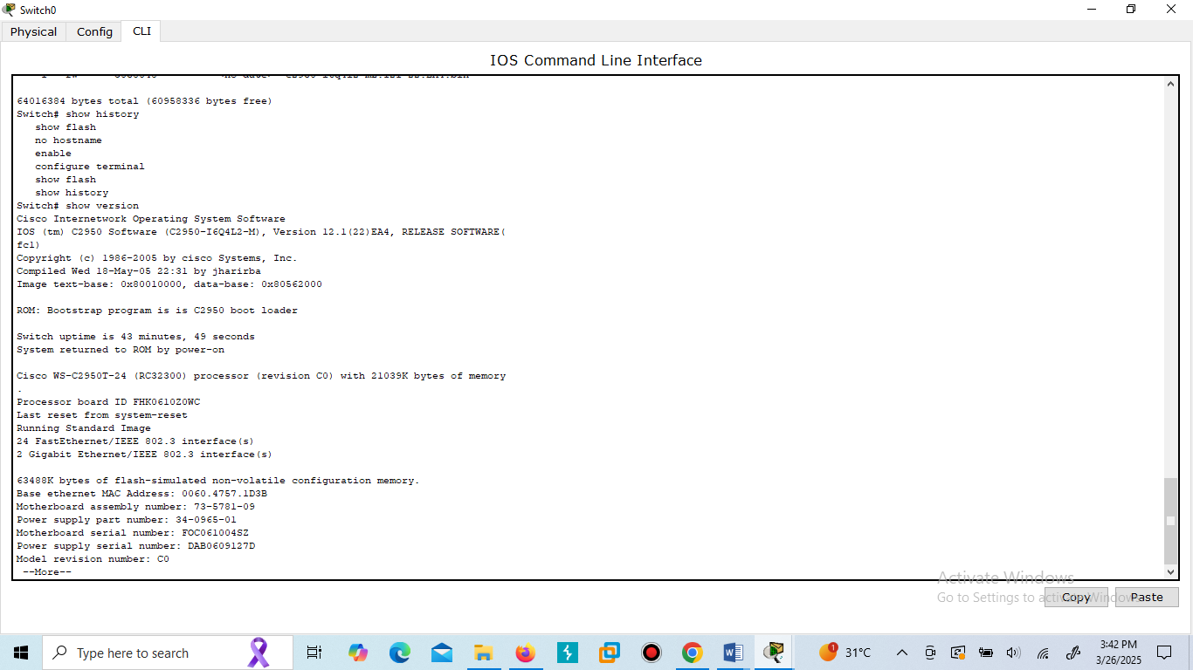

**Switch#show clock**

Will show you default Switch clock

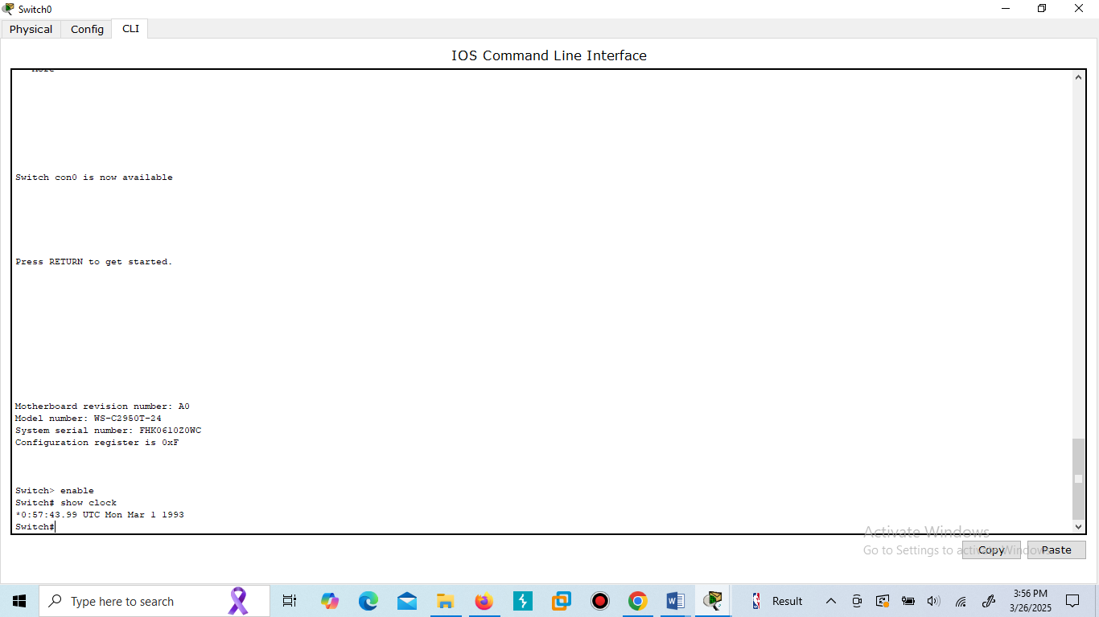

**Switch#show hosts**

Will display a cached list of hosts and all of their interfaces IP addresses

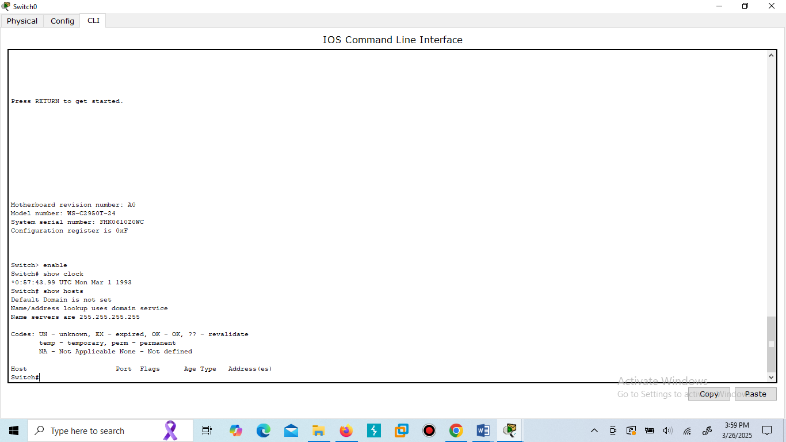**Switch#show users**

Will show a list of all users who are connected to the Switch.

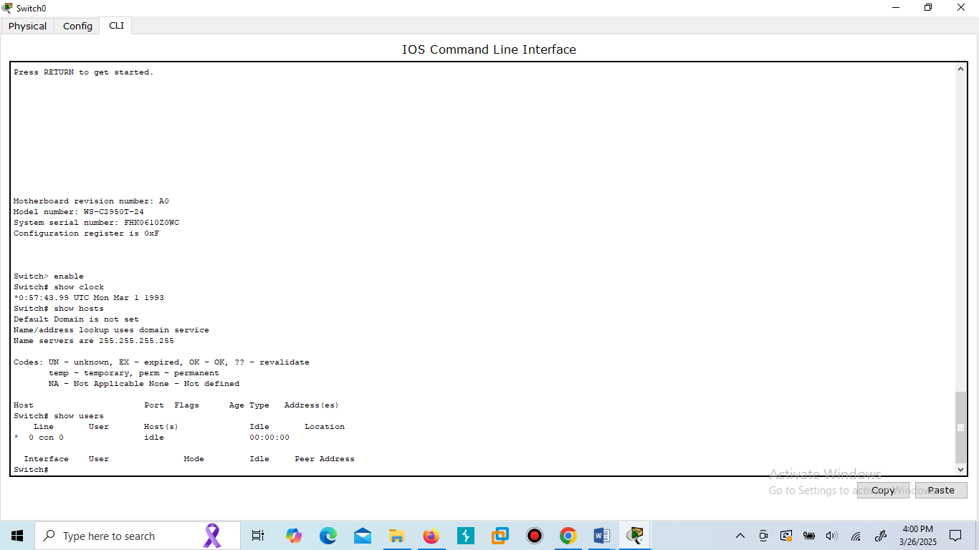

## Switch#show interfaces

Will give you detailed information about each and all kinds of interfaces used by the Switch. And also tell which interface UP, Down and Administratively down.

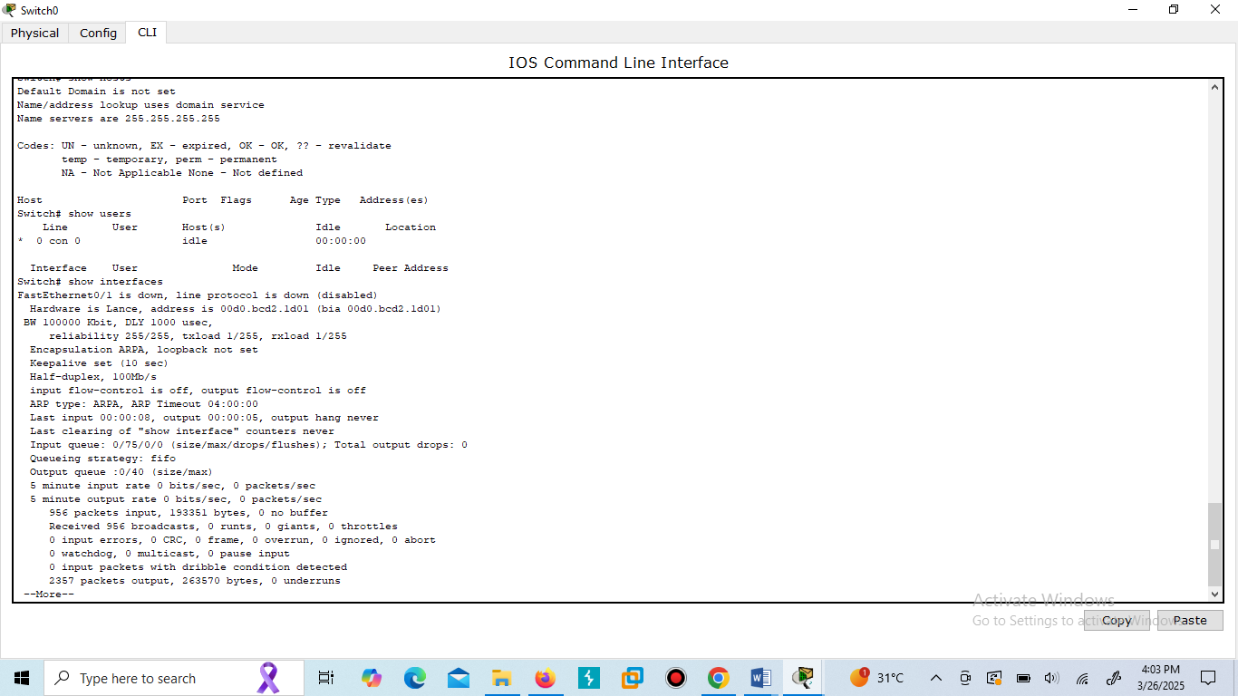

## Switch#show ip interface brief This command will show brief descriptions about interface. This command mostly used in troubleshooting. There may be three possible conditions of status UP :- interface is up and operational DOWN :- physical link is detected but there are some problem in configurations. Administratively down :- port is disable by shutdown command ( Default mode of any port on Switch.)

## Display the MAC address table information

Switch#show mac-address-table

This command will show the information about the MAC addresses

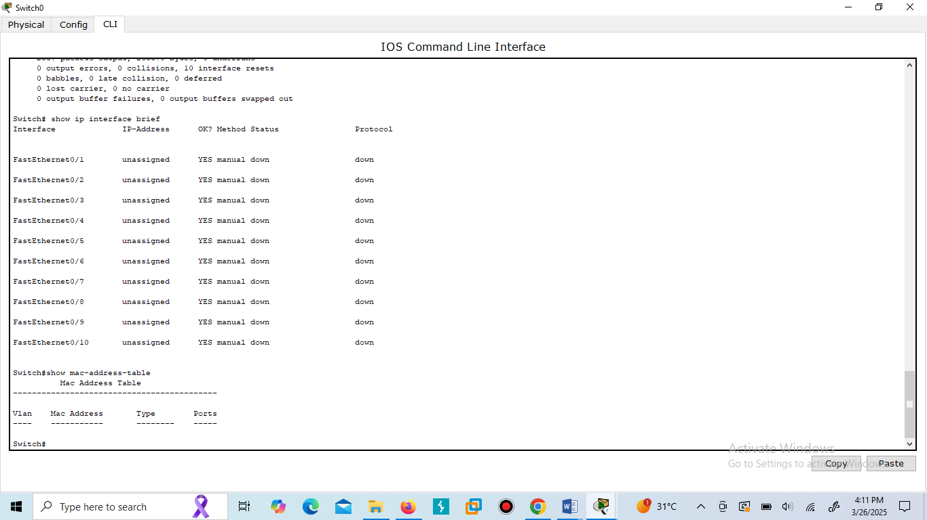

**LAB Home Work:**

Apply the following commands on router and switch and attach the results in the form of screen shot in lab file and also define the functions of the following commands and give required explanation of the results.

1. **Clock Set and then Show Clock**

On Router:

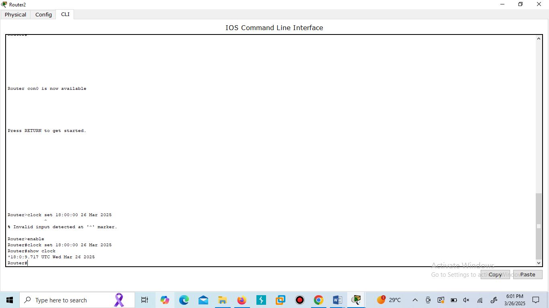

On Switch:

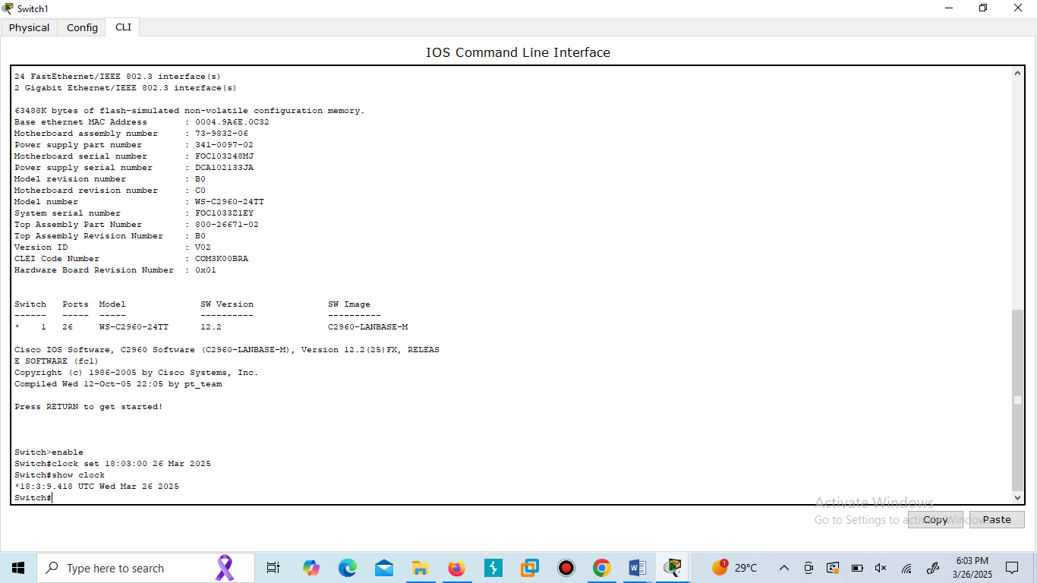

The clock set command is used to manually set the date and time.  
The show clock command displays the current clock time.

1. **Banner setting**

On Router:

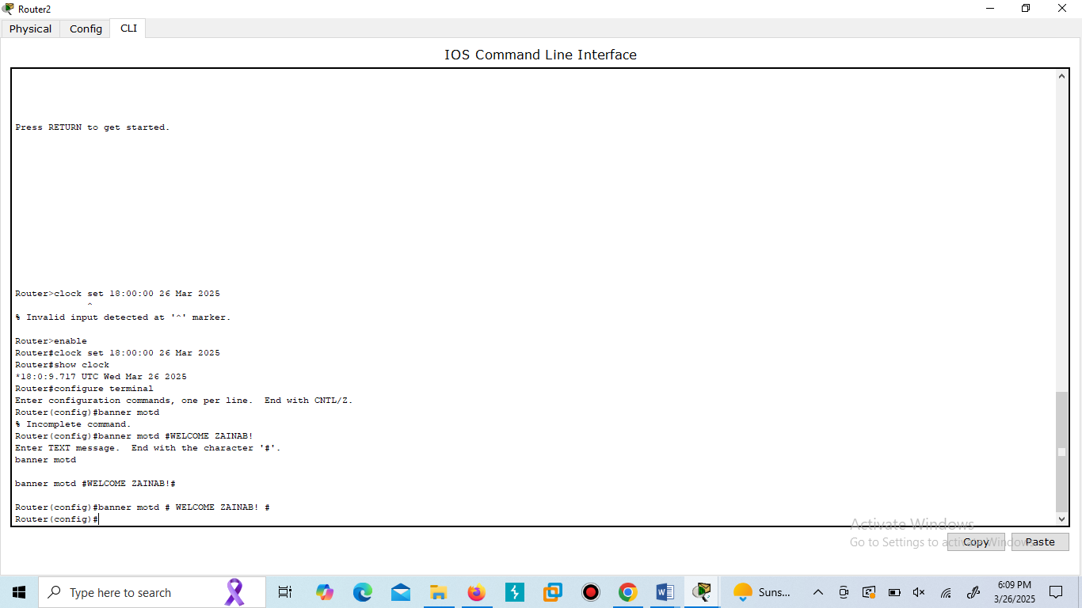

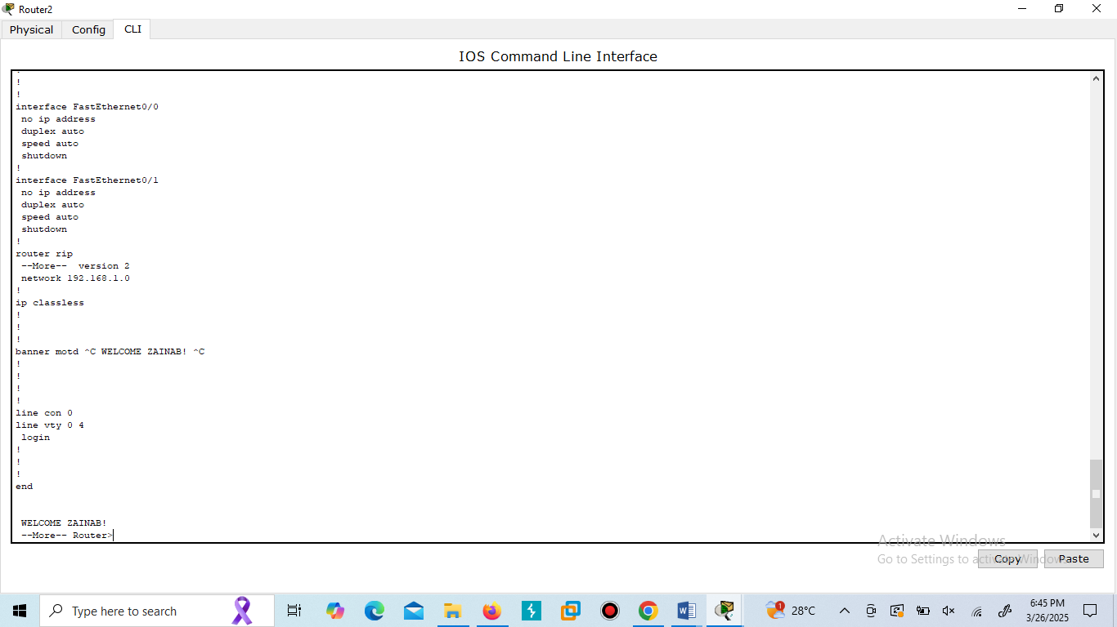

On Switch:

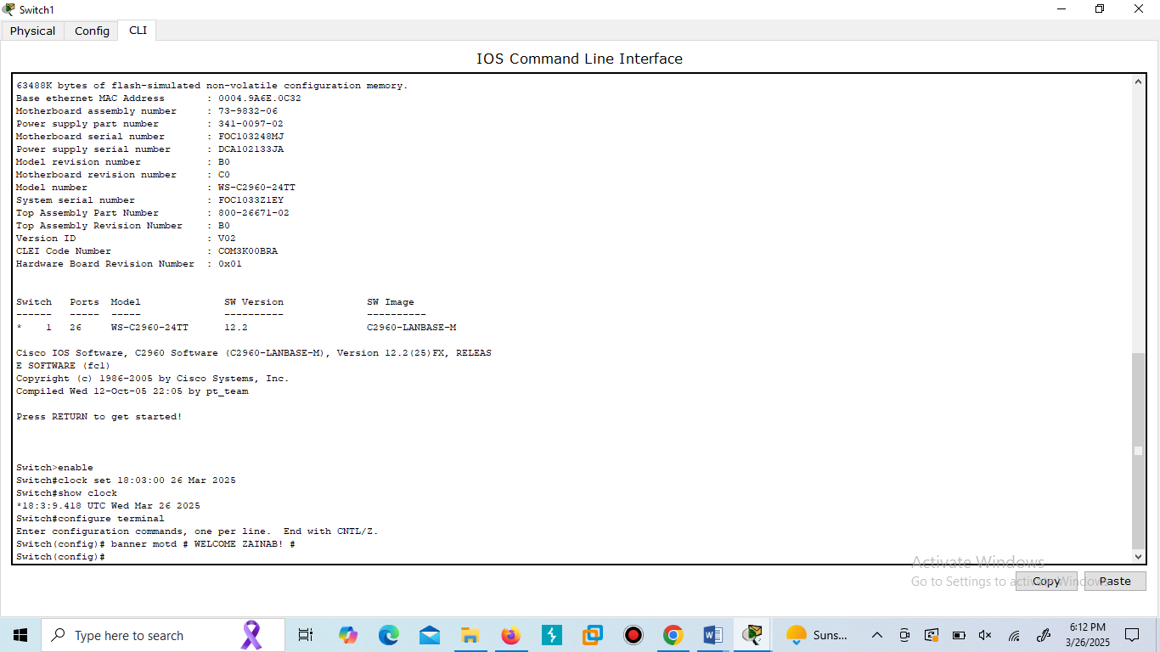

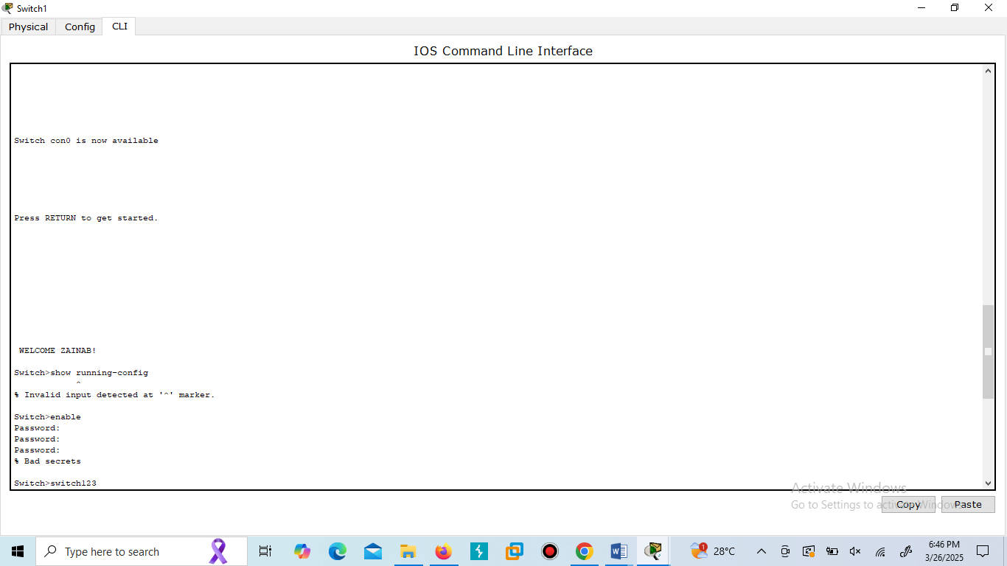

The banner motd command sets a **Message of the Day (MOTD)** banner displayed when users log in.

1. **Enable password**

On Router:

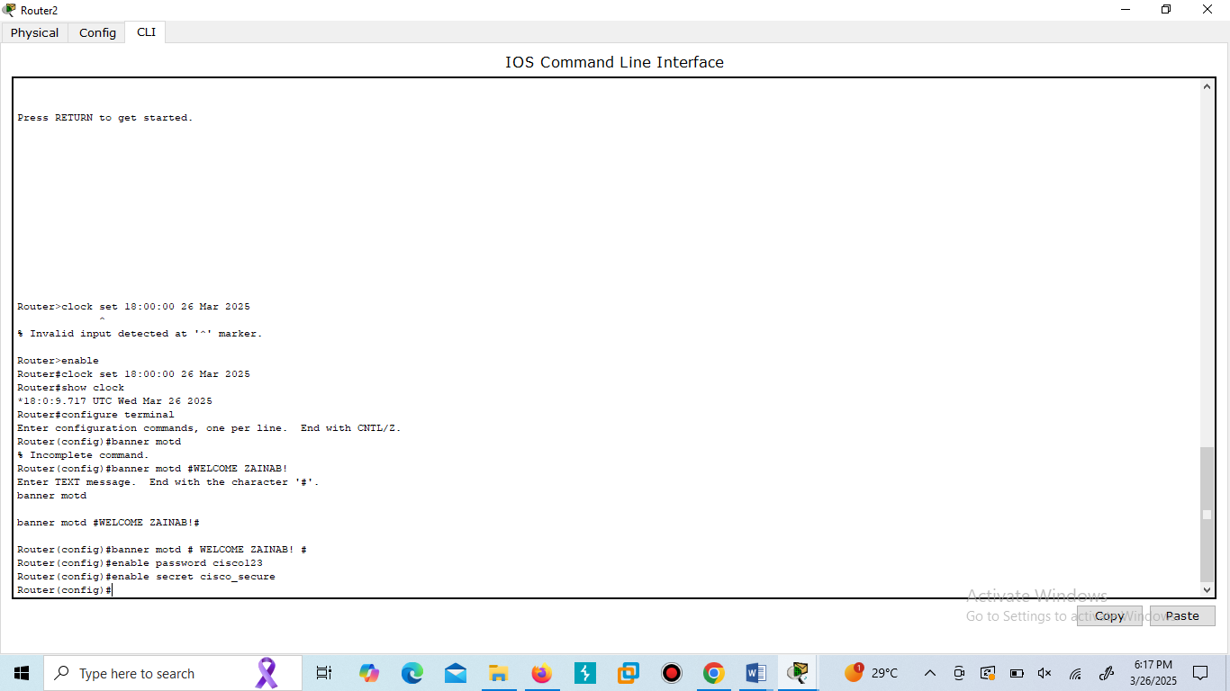

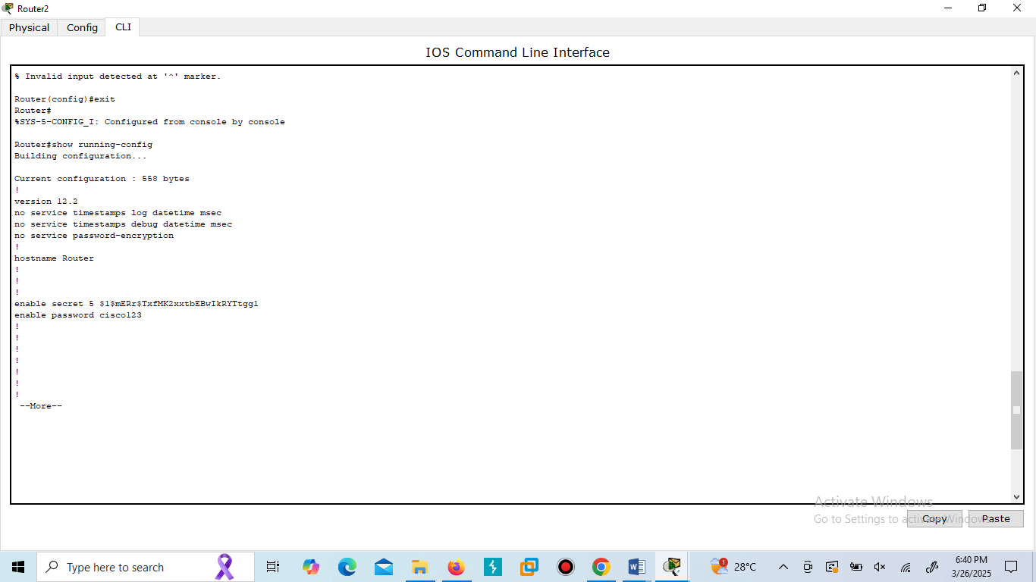

On Switch:

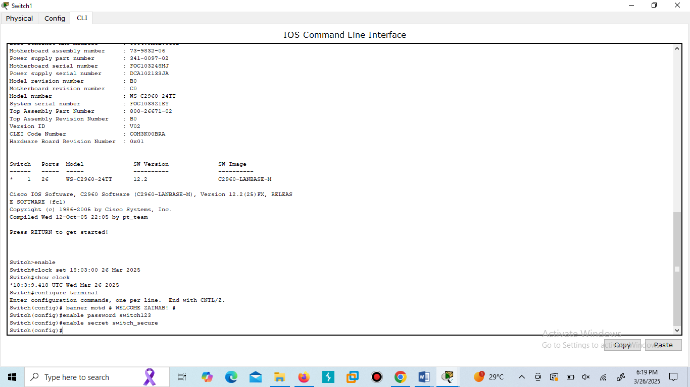

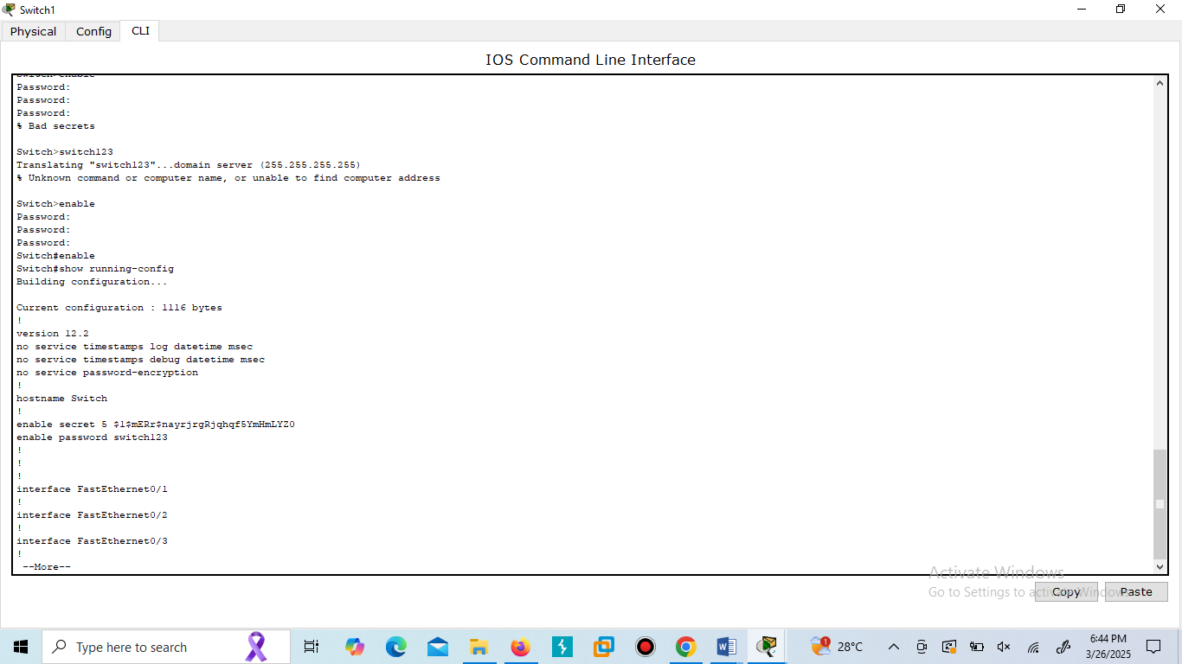 The enable password sets a password for privileged EXEC mode.

The enable secret is an encrypted version of the enable password.

**Conclusion:**  
In this lab, we explored the fundamentals of Cisco Packet Tracer and practiced using essential **show** commands on routers and switches. These commands help monitor device status, configurations, and network protocols—building a strong foundation for network troubleshooting and management.